Disability Matters Shepparton!

What: An information session about the free support available for the Shepparton community to contribute to the Disability Royal Commission.
Who: People with disability, friends, family, carers, advocates and supporters
When: Thursday 8 September at 12:00-1:30PM
Where: North Shepparton Community & Learning Centre – 10-14 Parkside Drive Shepparton (See Google Maps / Website / Accessibility Information)
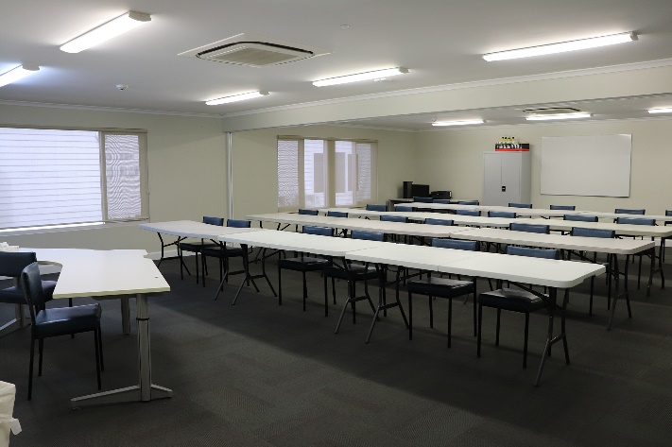
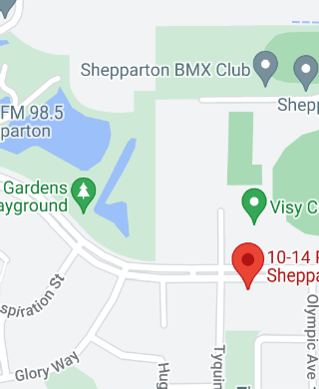
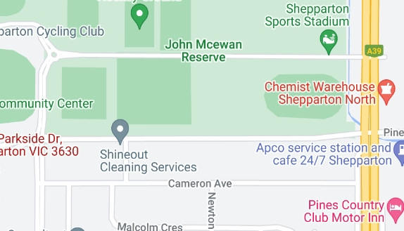
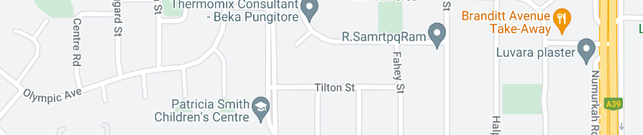
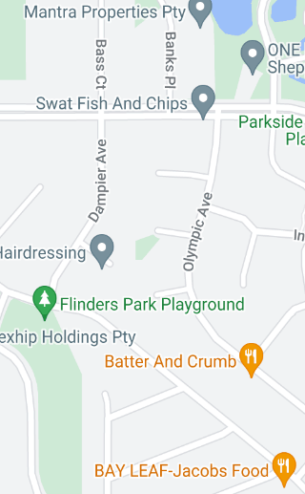
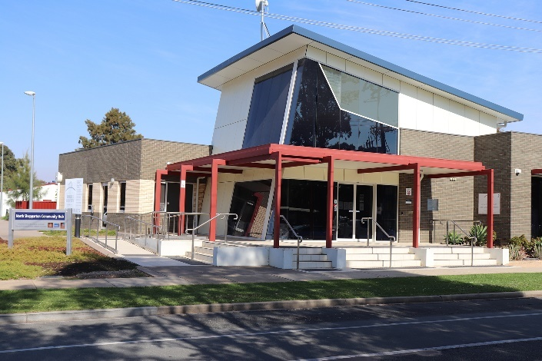
10-14 Parkside Dr, Shepparton VIC 3630
Room that the event will take place in. The chairs and tables seen in this image will not be present in this event. Image obtained from the NSCLC Website
Venue. Image obtained from the NSCLC Website

Accessibility
- Ramp access
- Automatic doors at front entrance
- Wheelchair access to all rooms/facilities within the venue
- Wheelchair access to bathrooms
- Motorised scooter rechargeable port
- Gravel surface outside of building
- Carpeted surface inside building
- Couches and seating directly outside the event room (please note: other rooms within this building will be occupied at the time of the event)

Please let us know of any other accessibility and dietary requirements when you register to get your ticket.
Transport
- Onsite parking
- Bus stop (No.3, Stops at: Parkside Drive/Tyquin Street) located around the side of the building on Tyquin St
- Two dedicated accessible parking spots directly in front of the building

Event details
The Disability Royal Commission is investigating the mistreatment of people with disability and wants to hear from people with:
- lived experience of disability
- their family members,
- friends,
- carers,
- advocates
- supporters.

Come along to this information session to find out how you can access free support to share your stories and ideas for making Australia safer and more inclusive of people with disability.

This information session will provide:
- Information about the Disability Royal Commission and the free legal, counselling and advocacy supports available
- Demonstrations on how to share your story and ideas for change with the Disability Royal Commission
- Access to onsite support staff to answer your questions about the Disability Royal Commission
- Support to book follow up appointments for free legal, advocacy and counselling support

Contact details
For more information, contact Your Story Legal Support on 1800 77 1800 (free call) or visit the website for other ways to get in touch.

Event hosts
This event is hosted by Your Story Disability Legal Support, Relationships Australia Victoria, Rights Information and Advocacy Centre, Drummond Street Services and Leadership Plus. We will have representatives from each organisation joining us for this event.

Acknowledgment of Country

We would like to acknowledge the Yorta Yorta people of the land which now comprises Greater Shepparton, where this event is taking place. We would like to pay our respects to their Elders past, present and emerging.

